

King Fahd University of Petroleum & Minerals

College of Computer Science and Engineering

Information and Computer Science Department

First Semester 111 (2011/2012)

ICS 202 – Data Structures

Major Exam 2

Thursday, December 1st, 2011

Time: 90 minutes

Name: _______________________________________________

|  |  |  |  |  |  |  |  |  |  |
| --- | --- | --- | --- | --- | --- | --- | --- | --- | --- |
| ID# |  |  |  |  |  |  |  |  |  |

|  |  |  |  |  |
| --- | --- | --- | --- | --- |
| Section 02 |  | Question # | Max Marks | Marks Obtained |
| Dr. Wasfi |  | 1 | 20 |  |
| 10-10:50am |  | 2 | 20 |  |
| Section 05 |  | 3 | 25 |  |
| Dr. Sami |  | 4 | 15 |  |
|  |  | 5 | 20 |  |
| 9-9:50am |  | Total | 100 |  |

**Instructions**

1. **Write your name and ID in the respective boxes above and circle your section.**
2. **This exam consists of XXX pages, including this page, plus one double-sided reference sheet, containing 4 questions.**
3. **You have to answer all 4 questions.**
4. **The exam is closed book and closed notes. No calculators or any helping aids are allowed.**
5. **Make sure you turn off your mobile phone and keep it in your pocket if you have one.**
6. **The questions are not equally weighed.**
7. **The maximum number of points for this exam is 100.**
8. **You have exactly 90 minutes to finish the exam.**
9. **Make sure your answers are readable.**
10. **If there is no space on the front of the page, feel free to use the back of the page. Make sure you indicate this in order not to miss grading it.**

**Q.1 (20 points: 2x10):** Consider the following tree:

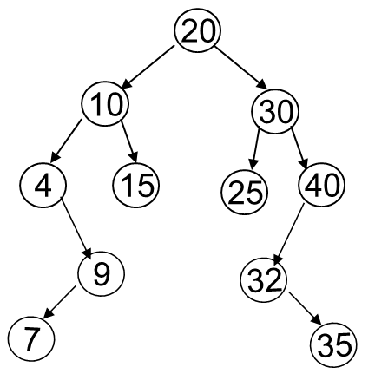

1. List the nodes of the left subtree of the root:
2. List the ancestors of node 15:
3. List the proper ancestors of node 15:
4. List the proper descendents of node 30:
5. What is the degrees of nodes 20, 15, and 32 respectively?
6. List all internal nodes of the above tree:
7. Are nodes 15 and 25 siblings?
8. What are the levels of nodes 7, 15, and 20 respectively?
9. What are the heights of nodes 30, 25, and 32 respectively?
10. Is the above tree full or complete?

**Q.2 (20 points):** Consider the following recursive java method that takes as input an array A of n real numbers, where n is a power of 2, and returns their average. Note that the first call to this method will be something like: value = AverageRec(A, 1, n);

public double AverageRec(double [] A, int low, int high) {

if (low == high) {

return A[low];

}

else { // n > 1

int m = (high – low + 1) / 2;

double avg_left = AverageRec(A, low, m);

double avg_right = AverageRec(A, m+1, high);

return (avg_left + avg_right)/2;

}

}

1. (7 points) Derive the recurrence equation that describes the number of real number additions that are carried out by the algorithm.
2. (8 points) Solve the above recurrence equation, finding the closed form solution.
3. (5 points) Do you think that this algorithm will be faster than the iterative algorithm where all array values are added iteratively, and then the sum is divided by the number of elements? Justify your answer.

**Q.3 (25 points):** With respect to data compression:

1. (4 points) Define lossless compression and lossy compression.
2. (4 points) Can we apply lossy compression techniques to text data, as opposed to multimedia data like audio and video? Justify your answer.
3. (12 points) Generate the Huffman Coding Tree for the following message. Make sure you show all your intermediate work:

SheeSellSeeShellOnTheSeeShoree

1. (5 points) Derive the compression ratio for the above message.

**Q.4 (15 points):** With respect to AVL Trees

1. (5 points) Insert the following keys into an initially empty AVL tree, showing all your work.

1 , 3 , 5 , 7 , 9 , 4

1. (10 points) Delete key 60 from the following AVL Tree, showing all your work.

**Q.5 (20 points):**

a) Show the steps of enqueuing the following values (in the following order) into a priority queue (Min Heap):

14, 8, 10, 7, 12, 5, 6, 7

b) Assume that three values have to be dequeued from the priority queue. Show the priority queue after each dequeue operation.

1. What is the output of each one of these invocations on the root node of the above (a) priority queue:
2. breadthFirstTraversal(v)
3. preorderTraversal(v)
4. inorderTraversal(v)
5. postorderTraversal(v)